NovaPoshta registration

Created on 06/19/2018.

To receive a key in NovaPoshta service you need to register and enter your personal account.

1. 1. To register an account, click on the link <https://novaposhta.ua/> and click on the "Register" button.

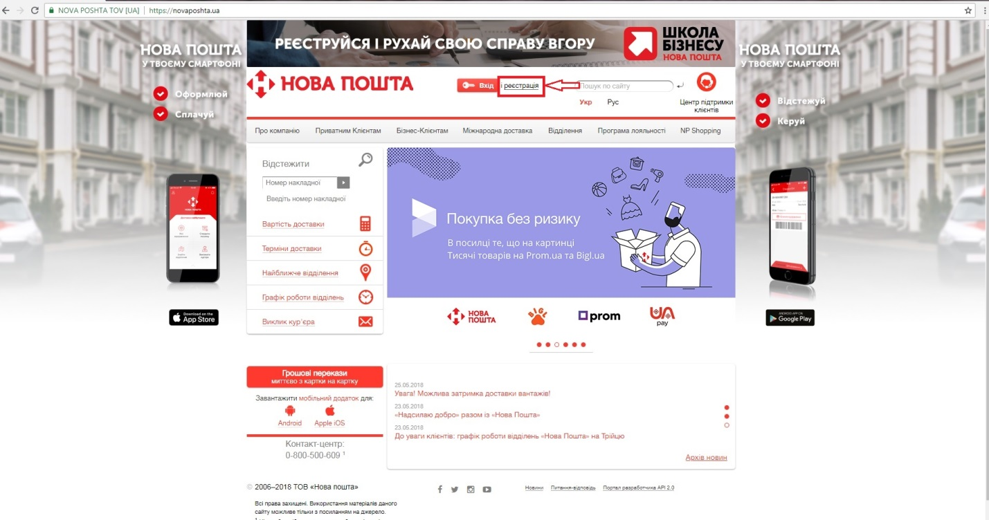

2. Enter all the necessary data for registration and click on the "Register" button.

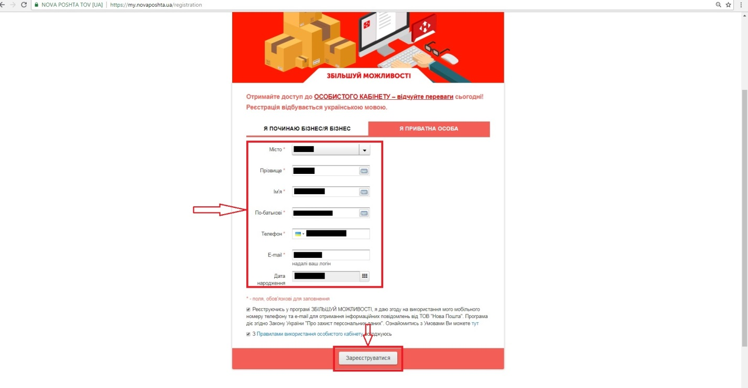

2. Then, after confirming the phone number and e-mail, go to the login page in your personal account.

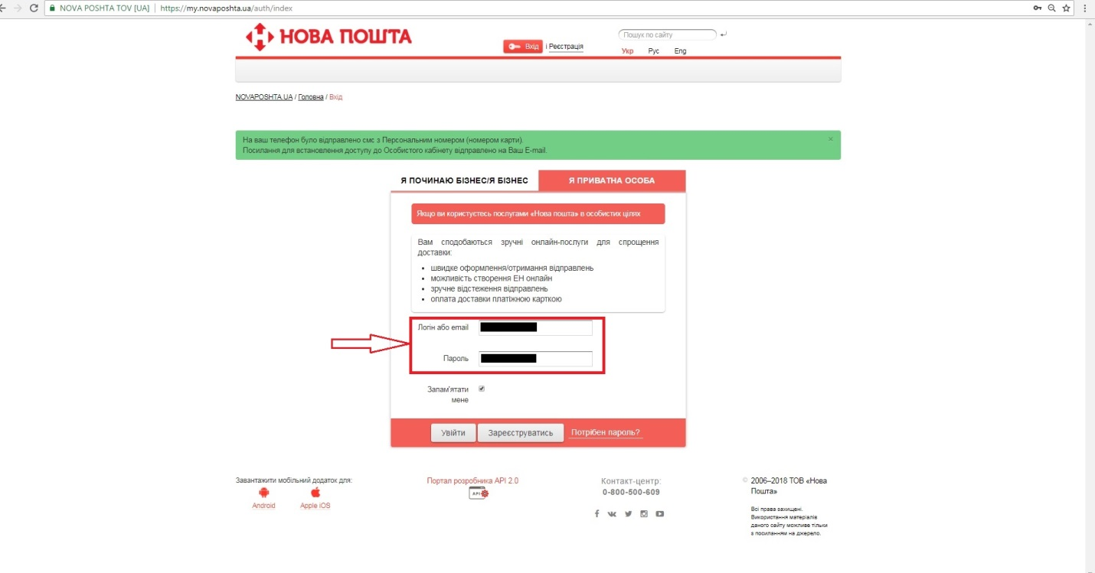

2. In the personal account, go to the "Settings" tab.

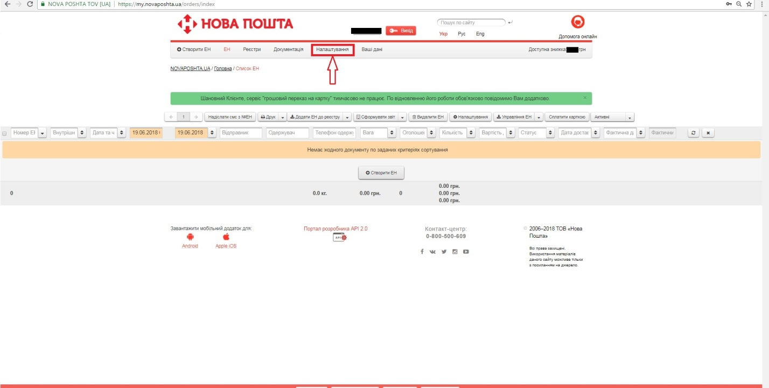

2. Next, go to the "API 2.0" tab.

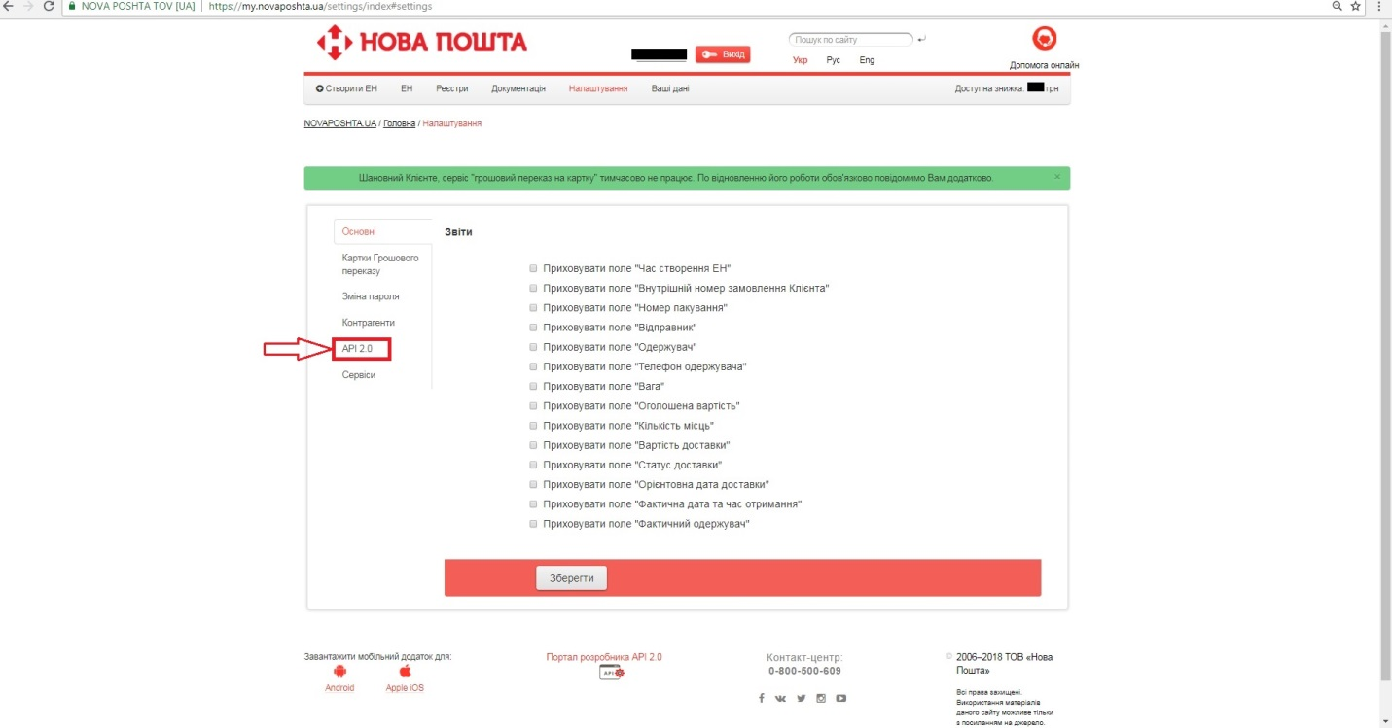

1. We click on the button «Create a new key» and get the key that we use as ClientId when authorizing the service.

